
Pius Karoki Kaveta
Bsccs/2024/47723
Bachelor Of Science In Computer Science

Bit4133: Natural Language Processing with Deep Learning

Project: Natural Language Processing Experiments Using Python, Nltk and Spacy
Technologies Used
- Python
- Google Colab
- Nltk
- Spacy
- Scikit-Learn

GITHUB
Github Repository: https://github.com/pius928/bit4133-nlp-deeplearning-logbook/tree/main
Lecturer Name: Mr Michael Nyoro

2026

Contents
WEEK ONE : Introduction to NLP and Text Processing 3
WEEK 2: N-Gram Models and POS Tagging 5
WEEK 3 : Named Entity Recognition and Sequence Labelling 7
WEEK 4: Dependency Parsing and Semantic Similarity 9
WEEK 5: Text Classification, Sentiment Analysis and NLP-Based Student Support Mini Chatbot 11

WEEK ONE : Introduction to NLP and Text Processing
Fig 1: Google Colab Environment Setup
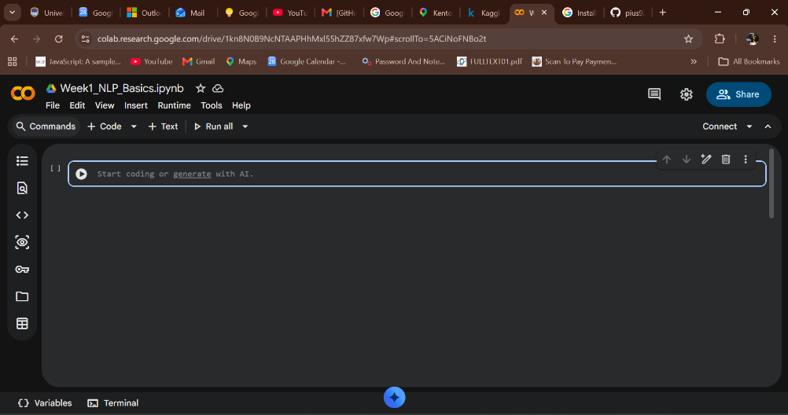
Fig 2: Python Test Execution in Google Colab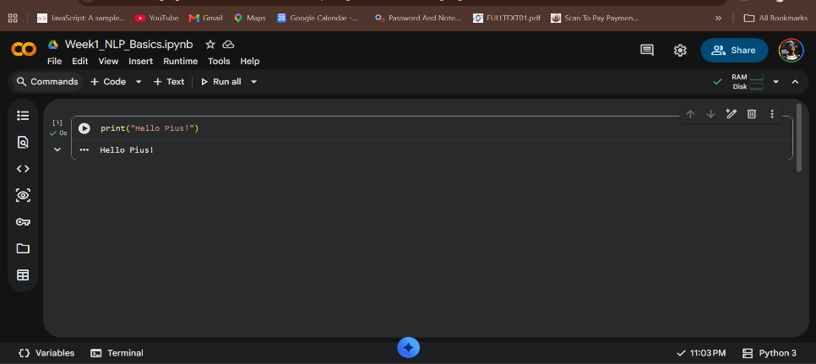
Fig 3: NLTK (Natural Language Toolkit) Installation in Google Colab
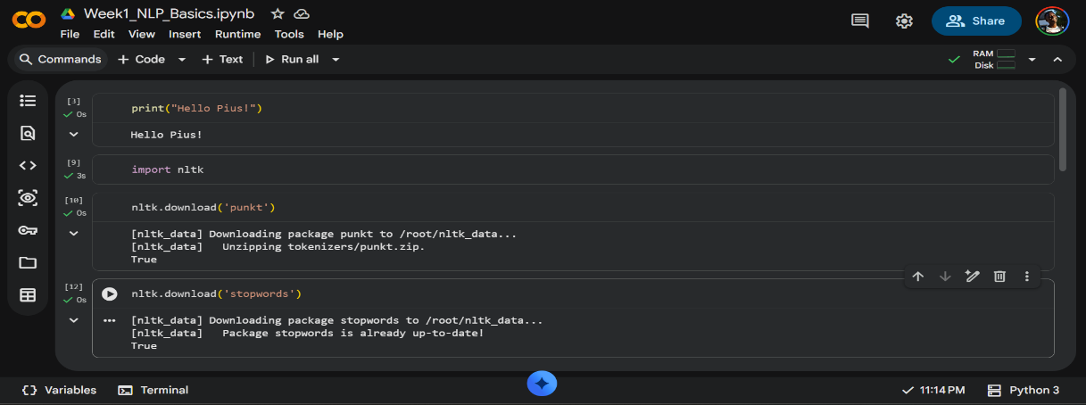

Fig 4: Tokenization Output Using NLTK
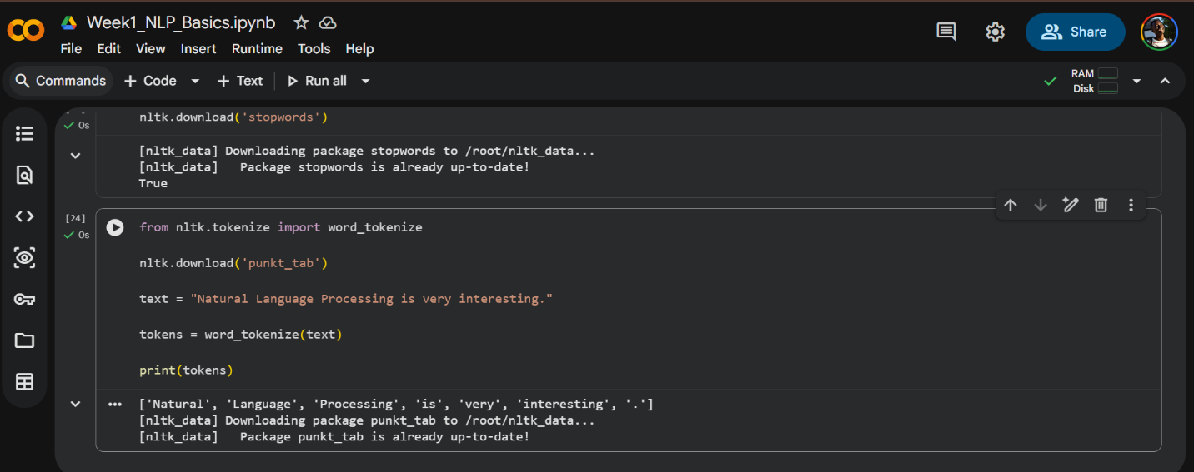
Fig 5: Stopwords Removal Output
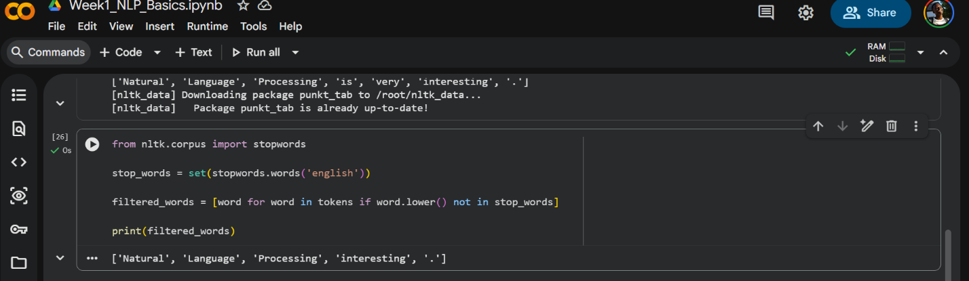
Fig 6: Example of NLP Application (DeepSeek AI)
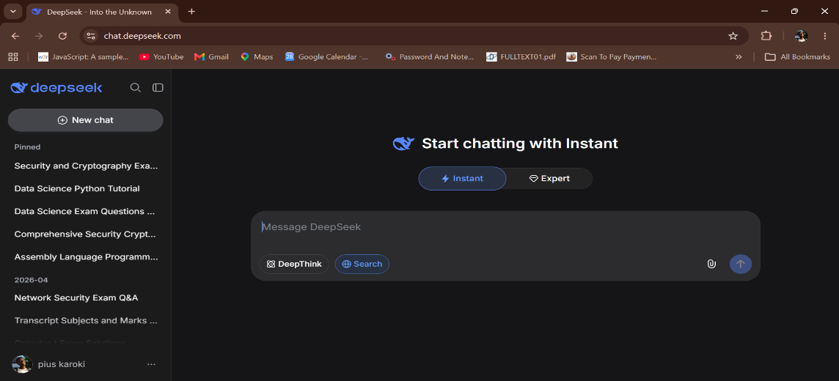
FIRST WEEK: This week I learned the basics of Natural Language Processing using Python and NLTK. I performed tokenization and stopwords removal, which helped me understand how text is prepared for machine learning models. I also explored real-world NLP applications such as DeepSeek.

WEEK 2: N-Gram Models and POS Tagging
Fig 1: Week 2 Google Colab Setup
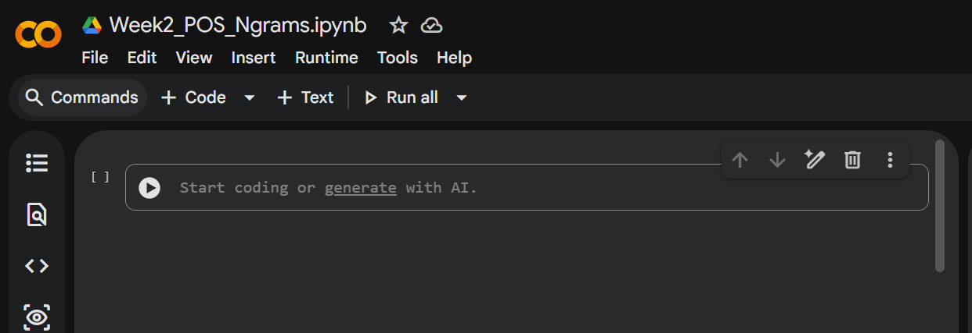
Fig 2: NLTK Libraries Downloaded
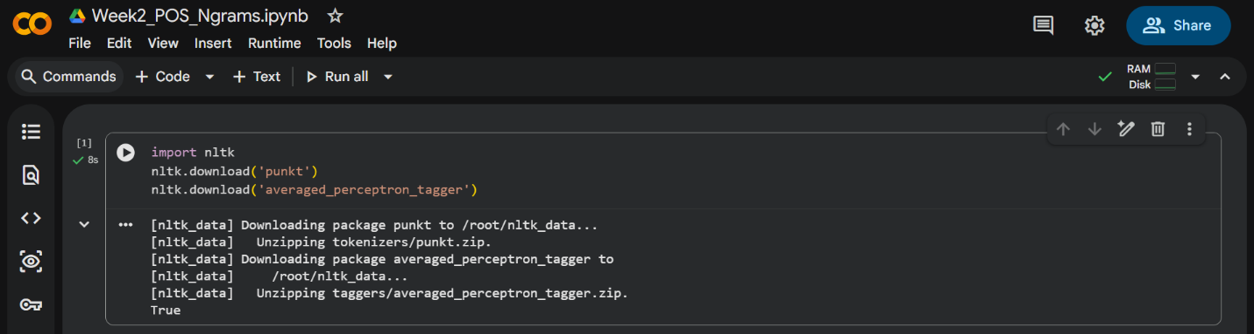
Fig 3: POS Tagging Output 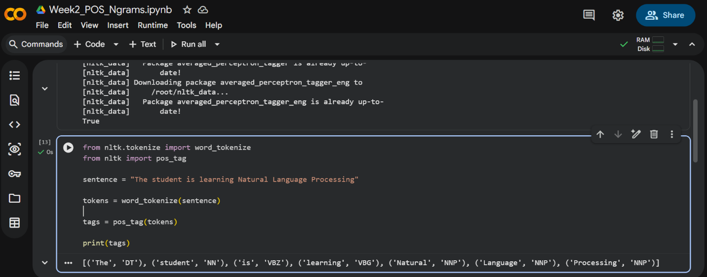
Fig 4: Bigram Output for N-gram Model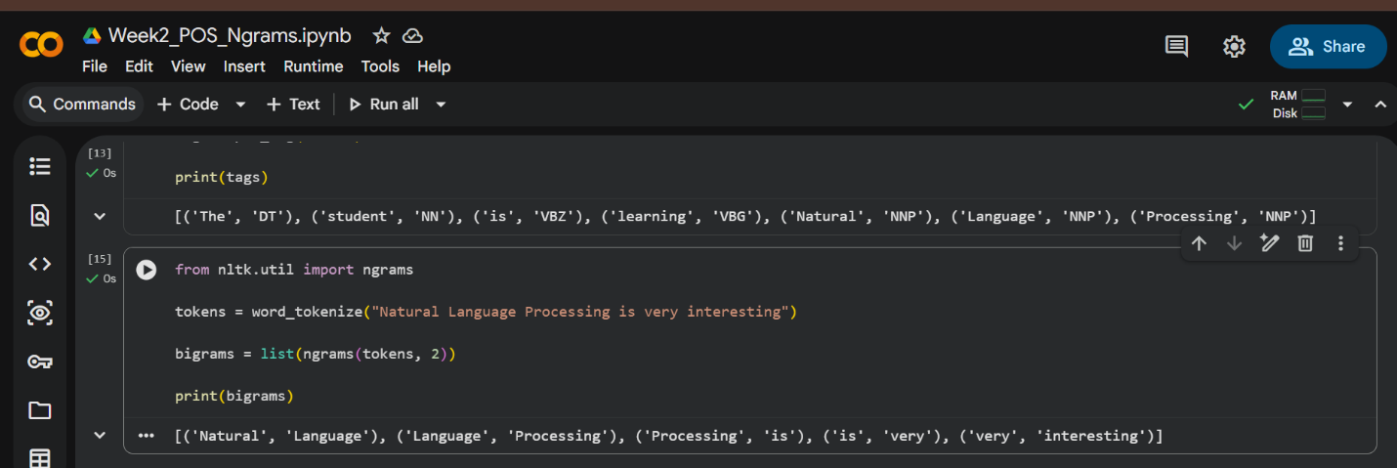
Fig 5: Trigram Output
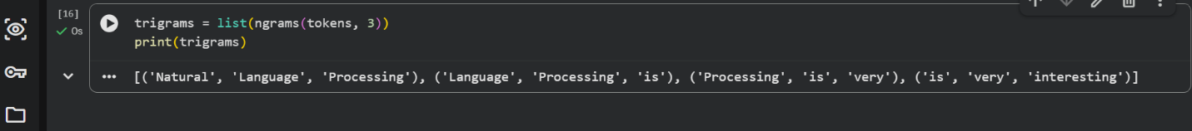
WEEK 2: This week I learned about N-gram language models and Part-of-Speech (POS) tagging using Python and NLTK. POS tagging helped identify grammatical roles of words such as nouns and verbs, while N-grams helped analyze word sequences in sentences. These techniques are important in machine translation, chatbots, and predictive text systems because they help computers understand sentence structure and word relationships.

WEEK 3 : Named Entity Recognition and Sequence Labelling
Learning how AI labels words (like names, places, actions) and understands hidden language patterns.
Fig 1: spaCy Installation
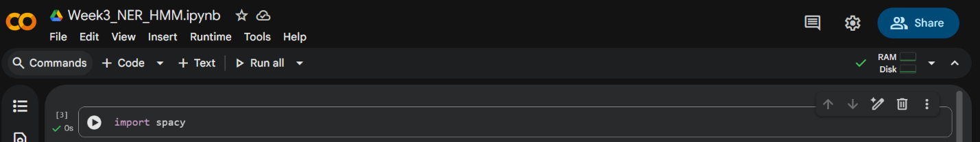
fig 2: Model Loading Output
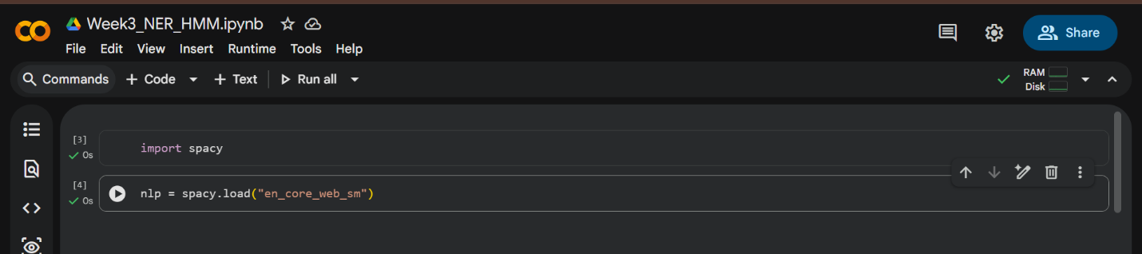
Fig 3: Named Entity Recognition (Ner)
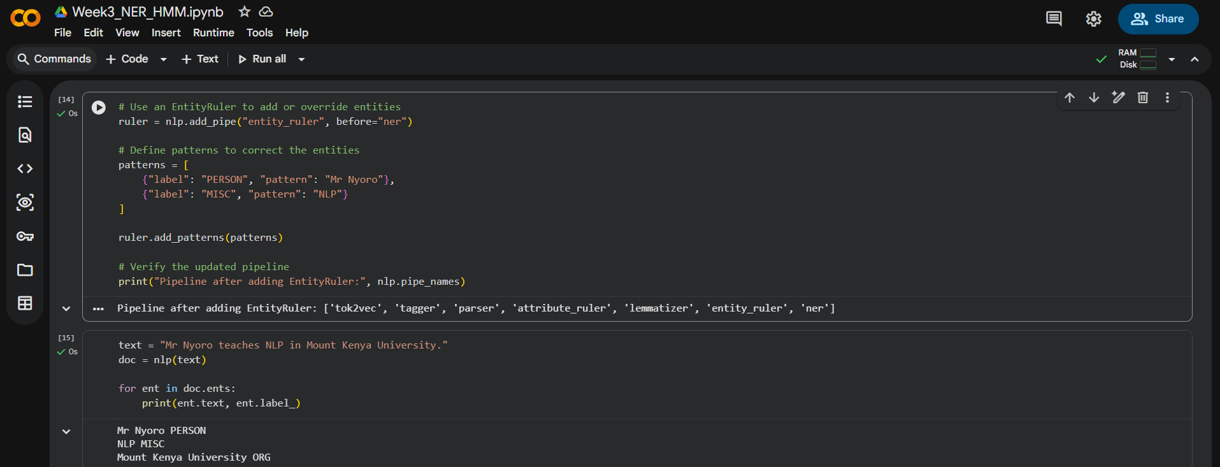
Fig 4: Sequence Labeling Output
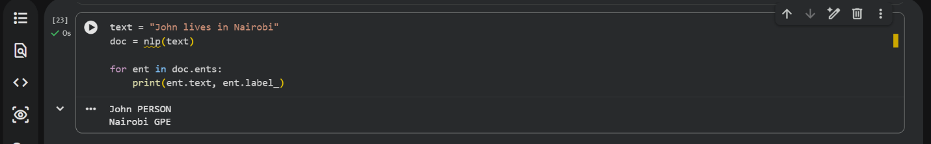

Fig 5: POS Tagging Output
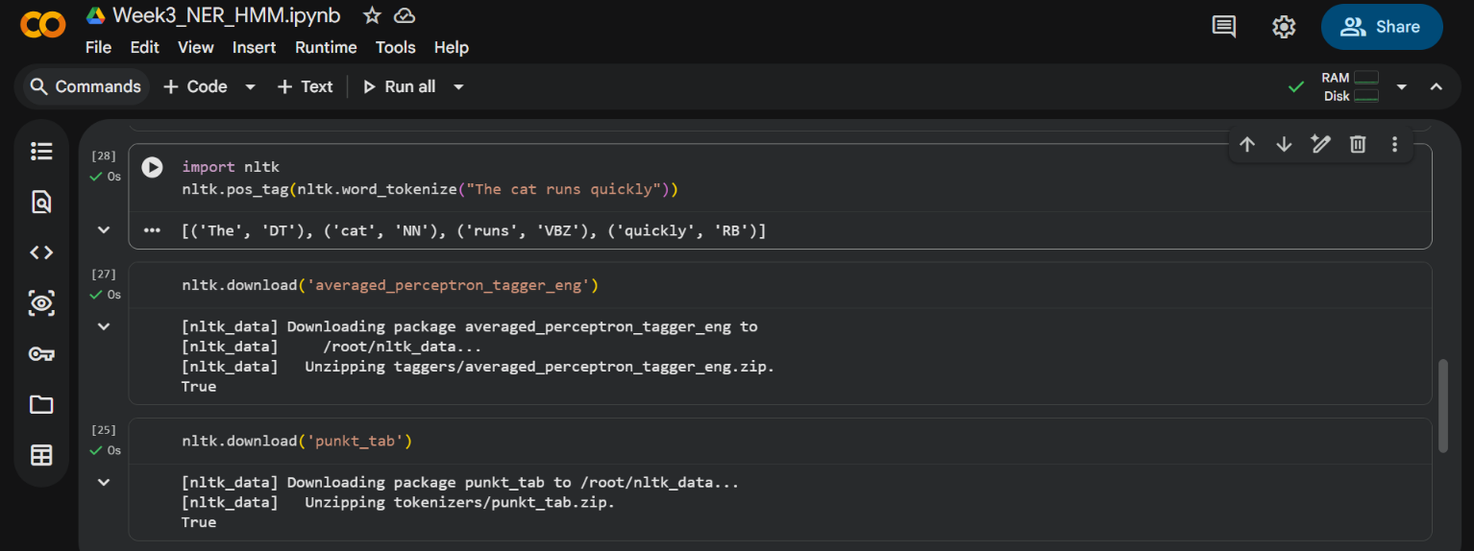
WEEK 3: This week I learned about Named Entity Recognition and sequence labeling using spaCy and NLTK. The system was able to identify names, locations, and organizations from text. These techniques are important in AI systems such as chatbots, search engines, and information extraction tools.

WEEK 4: Dependency Parsing and Semantic Similarity

spaCy
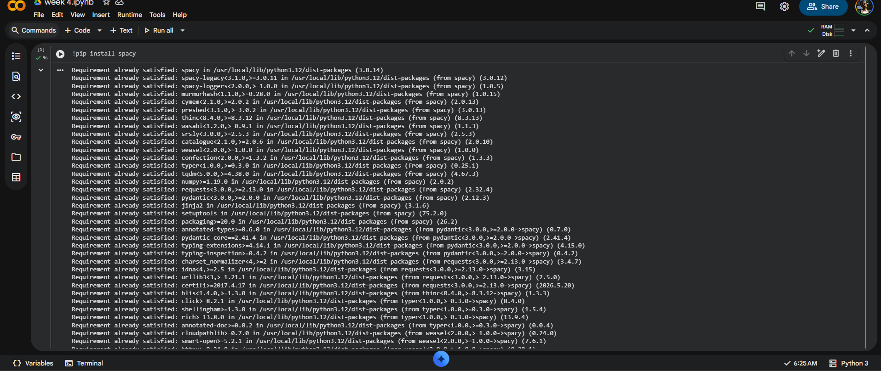

Fig 2: Language Model Download
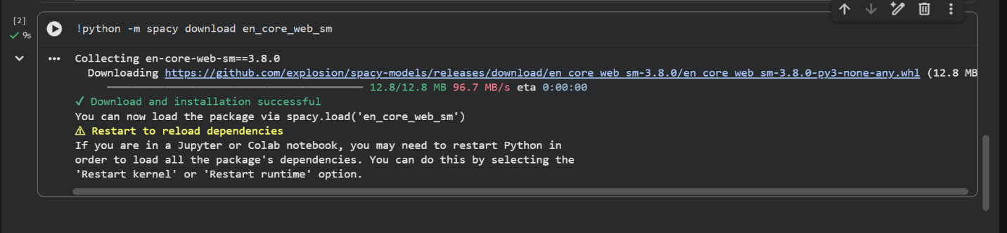
Fig 3: Dependency Parsing Output
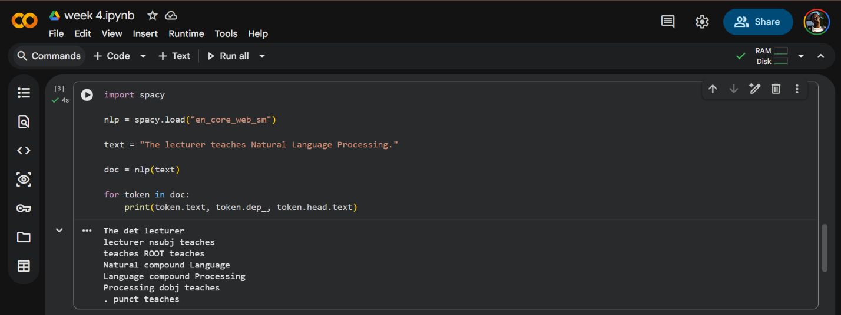

Fig 4: Semantic Similarity Output
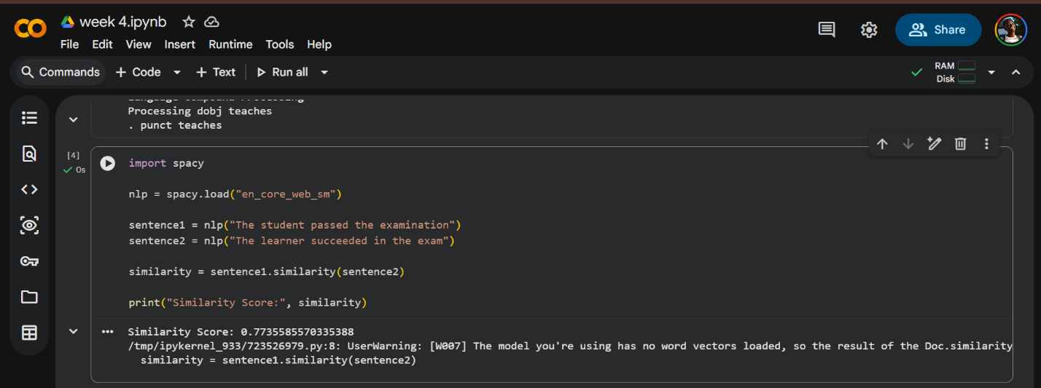
Fig 5: Similarity Score Result
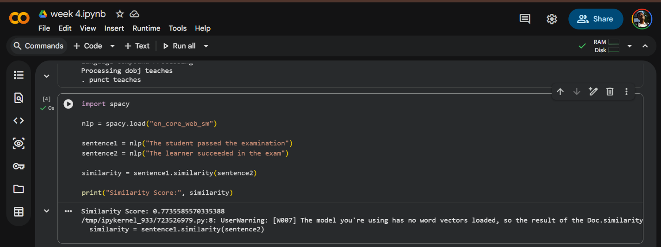

WEEK 4: During this week, I learned how NLP systems analyze sentence structure and meaning using dependency parsing and semantic similarity techniques. I used spaCy to identify relationships between words and compare sentence meanings. These practical activities improved my understanding of how AI systems interpret natural language and understand context.

WEEK 5: Text Classification, Sentiment Analysis and NLP-Based Student Support Mini Chatbot
Fig 1: Importing Libraries

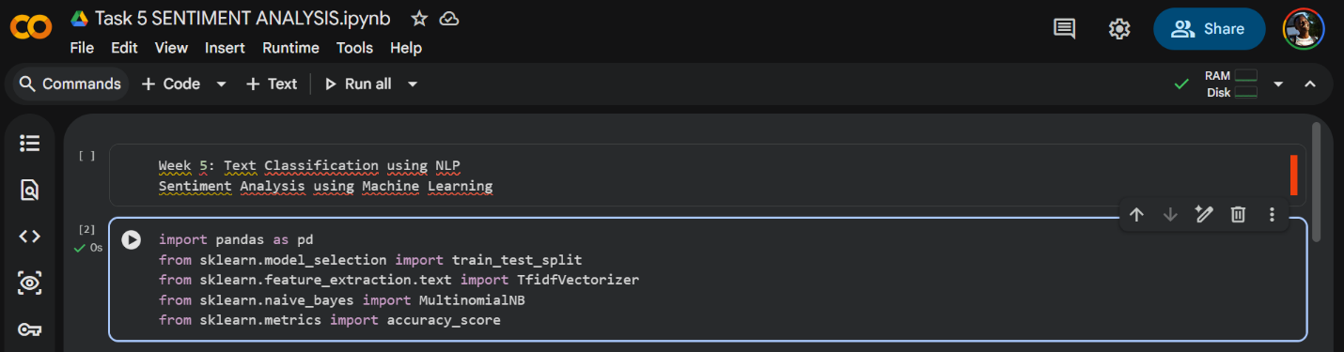
Fig 2: Dataset Creation
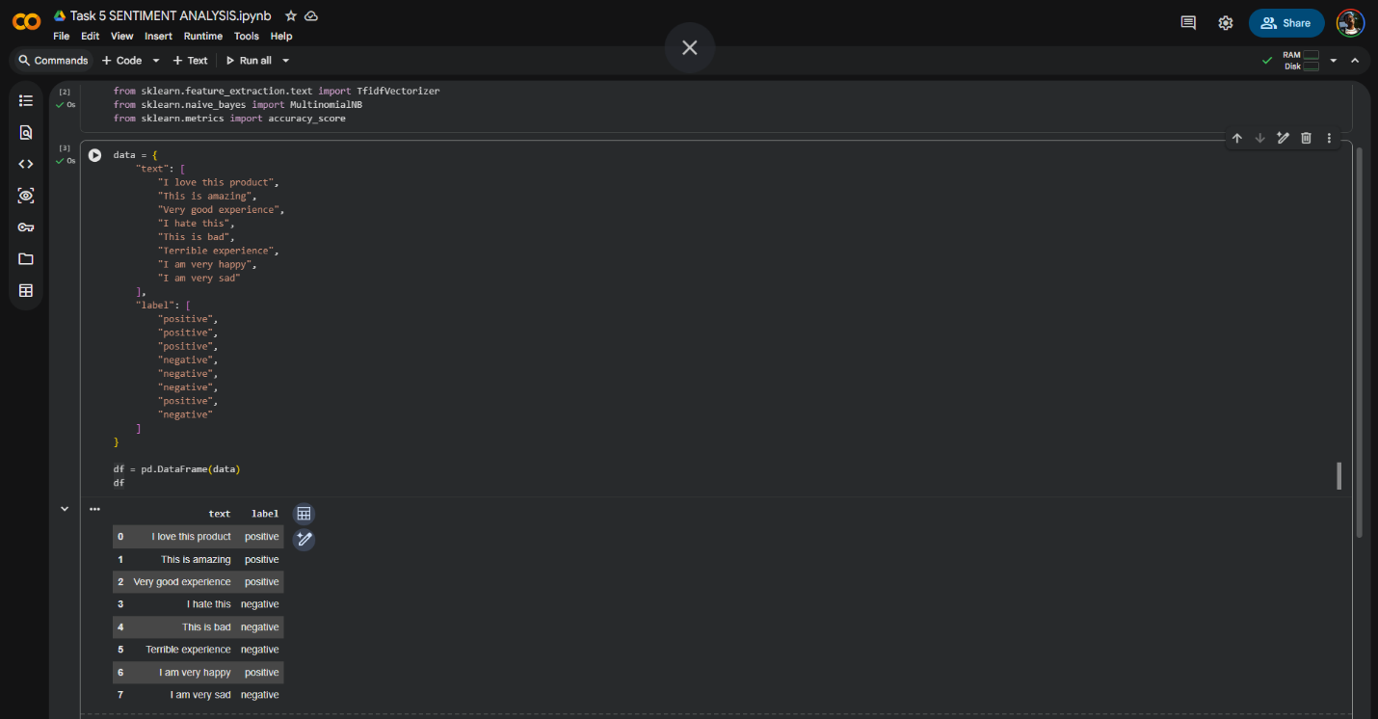
Fig 3: Data Splitting
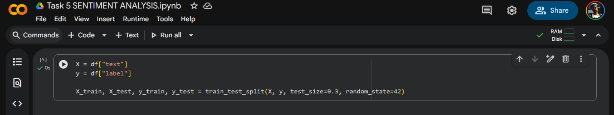

Fig 4: TF-IDF Feature Extraction
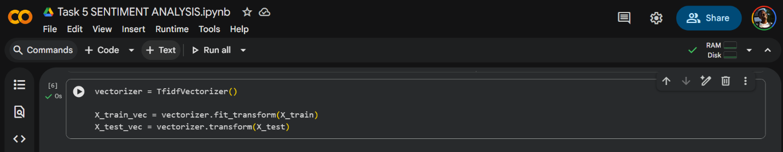
Fig 5: Model Training
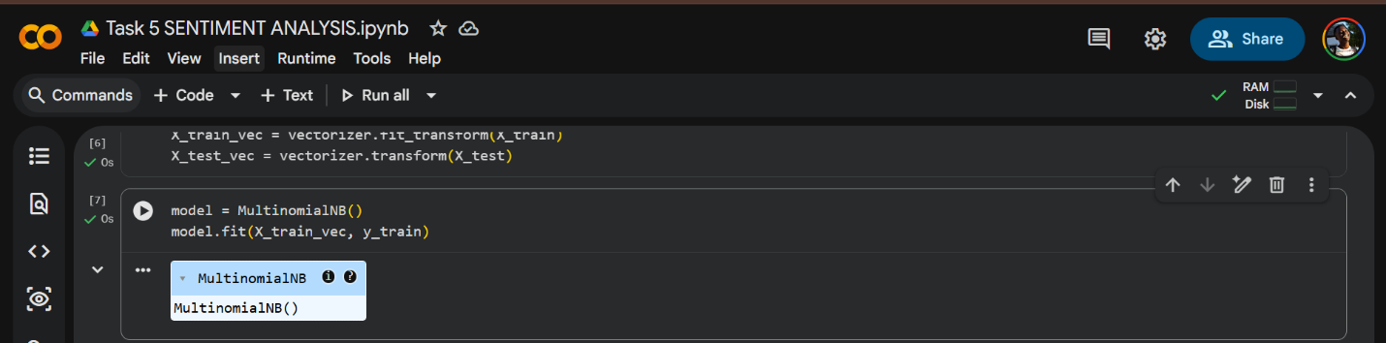
Fig 6: Prediction Output.
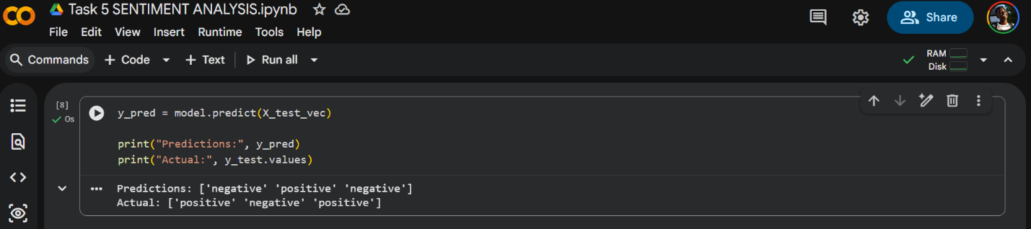

Fig 7: Model Accuracy
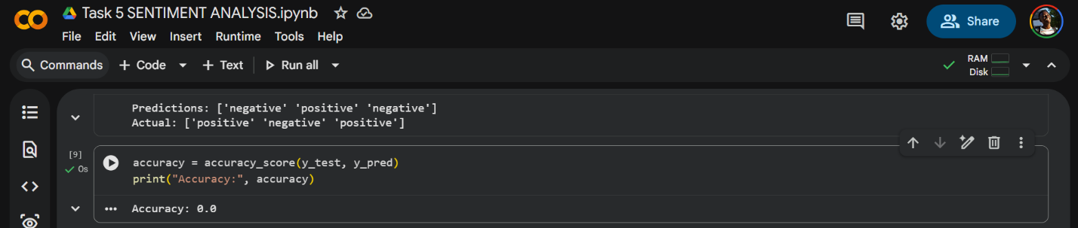
Fig 8: Custom Input Prediction
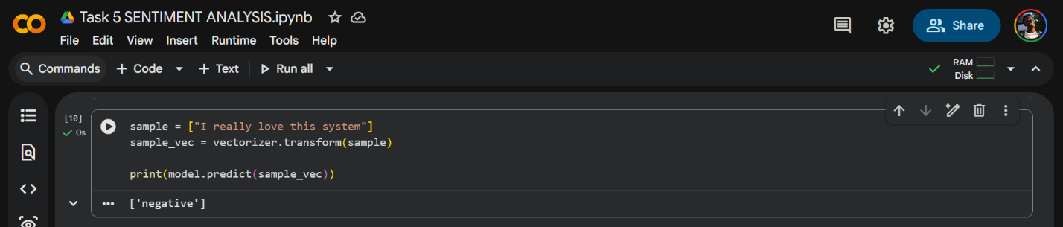

Fig 9: chatbot utilizes in basic NLP techniques
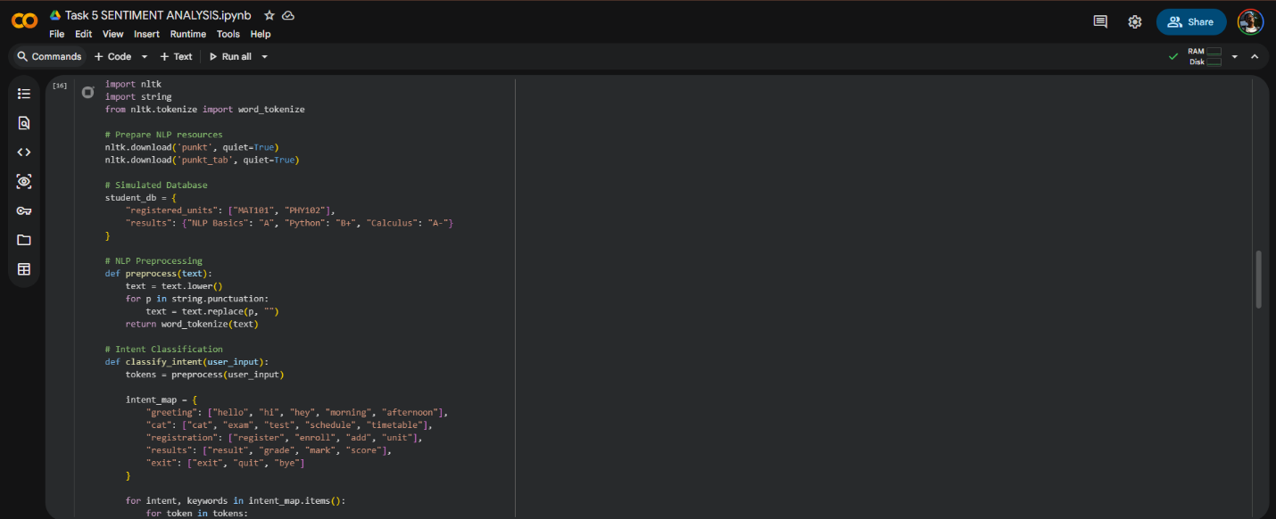
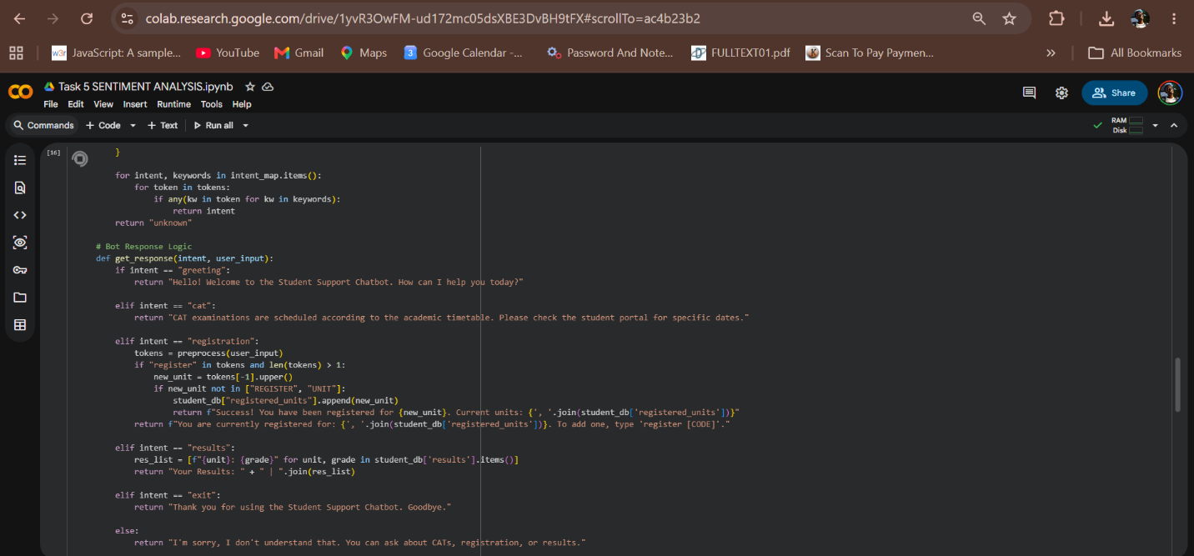
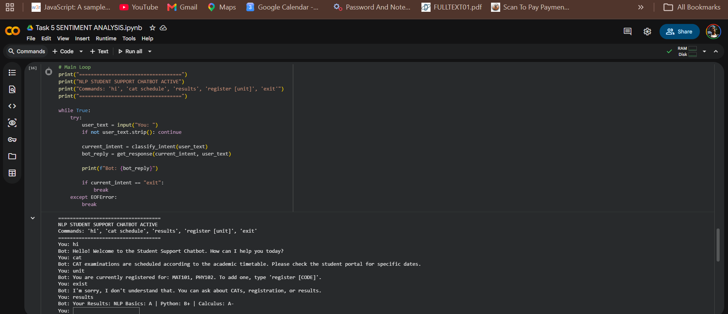

Week 5: This week I learned how to build a simple NLP chatbot using Python. The chatbot classifies user input into different categories and generates appropriate responses. This activity improved my understanding of conversational AI and intent classification.

